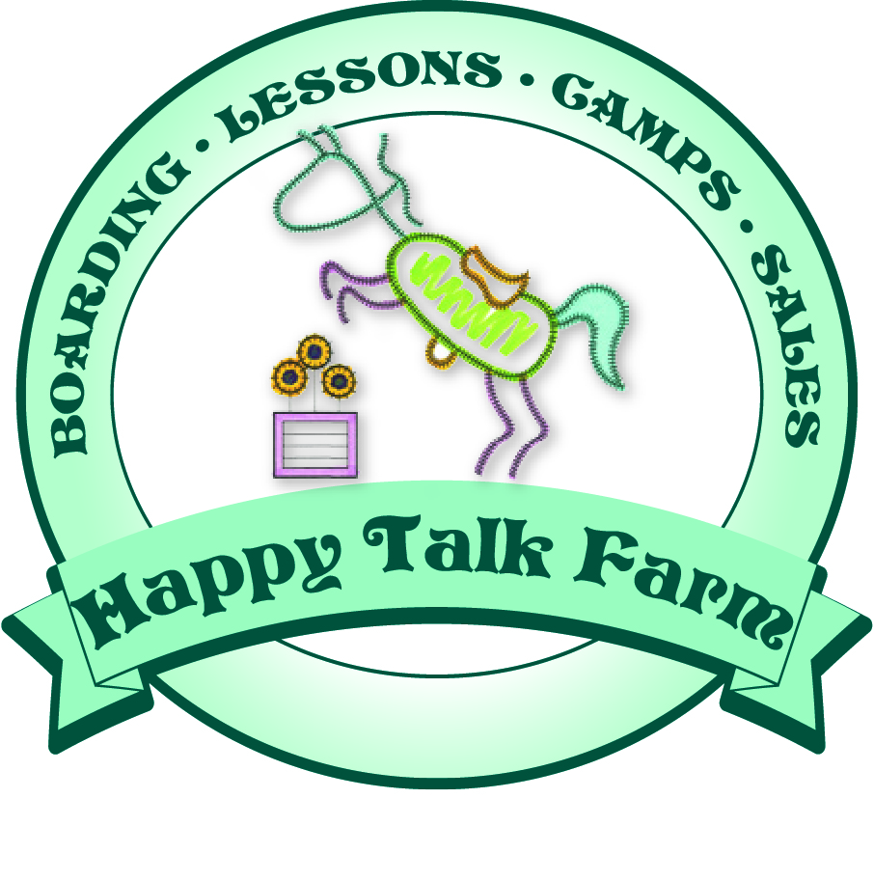
Happy Talk Farm Beat the Heat Mountain Retreat

We had such an incredible time last year, we are excited to head out again this summer. We hope you will join us in the Smokey Mountains for “cool” horseback riding, training, riding lessons and access to bountiful outdoor activities. Don’t miss the golf, train rides, whitewater rafting, hiking, biking, Cherokee Indian reservation and Biltmore House. Then there’s the fabulous shopping and galleries Asheville, Waynesville, Dillsboro, Highlands and Bryson City have to offer.
If you, your child or your horse are considering coming with us, below is our schedule. If you would like to visit, take riding lessons or trail ride, we welcome you. Not all trainers will be gone at the same time, so be assured that your lessons at home will continue.
July 7@ 4:00am – Trailers, horses, trainers, some kids and the jump course leave HTF for The Settlement at Thomas Divide, Bryson City, NC.
July - Aug. 4 – Horses stabled at Thomas Divide. We will have a riding arena, dressage arena and jump course, in addition to miles of trails for our use there.

Shipping Fees
$350 round trip. If fuel rises to $4/gall, prices will adjust accordingly.
Shipping fees to be paid: April 1 $100
May 1 $100
June 1 $100
July 1 $100

Stabling fees
$10/day (charged by barn at Thomas Divide) Horses will have hay and grain provided on same schedule as HTF.
Stabling fees to be paid: April 1 $100
May 1 $100
June 1 $100

We will bring barn help who will stay on site this year to manage the feeding and stall cleaning. She will be available for other services for a separate fee.
Daily stable care $5/day April 1 $50
May 1 $50
June 1 $50

Lesson/Training Assessment
$200. This fee is a charge to you for the duration of your horse’s stay and includes all trail rides. We plan to teach lesson in the same format as home. We will also be trail riding through 500 miles of trails. Your lesson fees and training fees will be credited off this amount. You may, of course, want more lessons or training rides. We will provide a settlement statement after we return home.

No Horse?
If you do not ship a horse, lease horses, lesson horses and trail riding horses are available with prior notice at HTF regular rates. If you are interested in participating in our wonderful trip, please contact Bonnie (813) 968-1168.

Housing
Bonnie has leased a lovely mountain home for the duration of the trip. It has 3 bedrooms, 2 baths, and a sleeper sofa. It is her hope that children and/or adults will join and share the cost. If you are interested in staying there, please contact her. She has already paid the deposit and room will be first-come, first-served with a deposit. Email Bonnie (bonnielouu@aol.com) for photos and details on the home.

For more details or questions, please contact Bonnie. Visit Bryson City and Thomas Divide websites for more information on activities in this mountain paradise.

